**Lab Report: 01**

**Title:** **Implementation of Algorithms for drawing 2D primitives**

Course title: Computer Graphics Laboratory

Course code: CSE-304

3rd Year 1st Semester Examination 2022

**Date of Submission**: 28.05.2023



**Submitted to-**

[Dr. Mohammad Shorif Uddin](https://juniv.edu/teachers/shorifuddin)

Dr. Morium Akter

Department of Computer Science and Engineering

Jahangirnagar University

Savar, Dhaka-1342

|  |  |  |  |
| --- | --- | --- | --- |
| **Sl** | Class Roll | Exam Roll | Name |
| 01 | 402 |  | Jubaer Ahmad Khan |

|  |  |  |
| --- | --- | --- |
| **Serial No.** | **Algorithm Name** | **Page No.** |
| 1 | Scan Conversion of a Point | 2 - 3 |
| 2 | Line Scan Conversion using DDA Algorithm | 3 – 4 |
| 3 | Line Scan Conversion using Bresenham’s Line Algorithm | 5 – 6 |
| 4 | Circle Scan Conversion using Bresenham’s Circle Algorithm | 6 - 7 |

# Algorithm Title: Scan Conversion of a Point

# Source Code:

#include<bits/stdc++.h>

#include<graphics.h>

int main()

{

float x,y;

printf("Enter X co-ordinate = ");

scanf("%f",&x);

printf("Enter Y co-ordinate = ");

scanf("%f",&y);

int gd= DETECT, gm;

initgraph(&gd, &gm, (char*)"");

putpixel(floor(x),floor(y),WHITE);

getch();

closegraph();

}

# GUI Output:

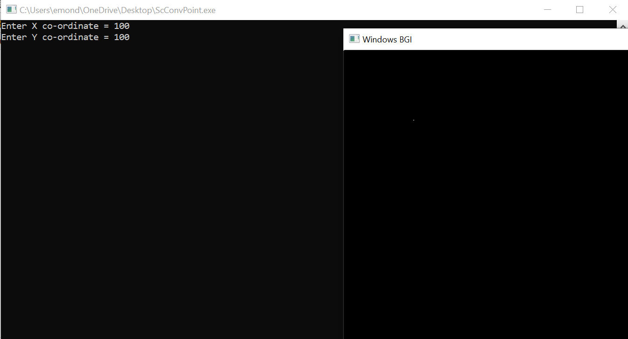

# Algorithm Title: Line Scan Conversion using DDA Algorithm

# Source Code:

#include <graphics.h>

void drawLine(int x1, int y1, int x2, int y2) {

int dx = x2 - x1;

int dy = y2 - y1;

int steps = abs(dx) > abs(dy) ? abs(dx) : abs(dy);

float xIncrement = static_cast<float>(dx) / steps;

float yIncrement = static_cast<float>(dy) / steps;

float x = x1;

float y = y1;

for (int i = 0; i <= steps; i++) {

putpixel(static_cast<int>(x), static_cast<int>(y), WHITE);

x += xIncrement;

y += yIncrement;

}

}

int main() {

int gd = DETECT, gm;

initgraph(&gd, &gm, (char*)"");

float x1, x2, y1, y2;

printf("Enter X1, X2 = ");

scanf("%f%f",&x1, &x2);

printf("Enter Y1, Y2 = ");

scanf("%f%f",&y1, &y2);

drawLine(x1, y1, x2, y2); // Draw the line from (x1, y1) to (x2, y2)

delay(5000); // Delay to show the output

closegraph();

return 0;

}

# GUI Output:

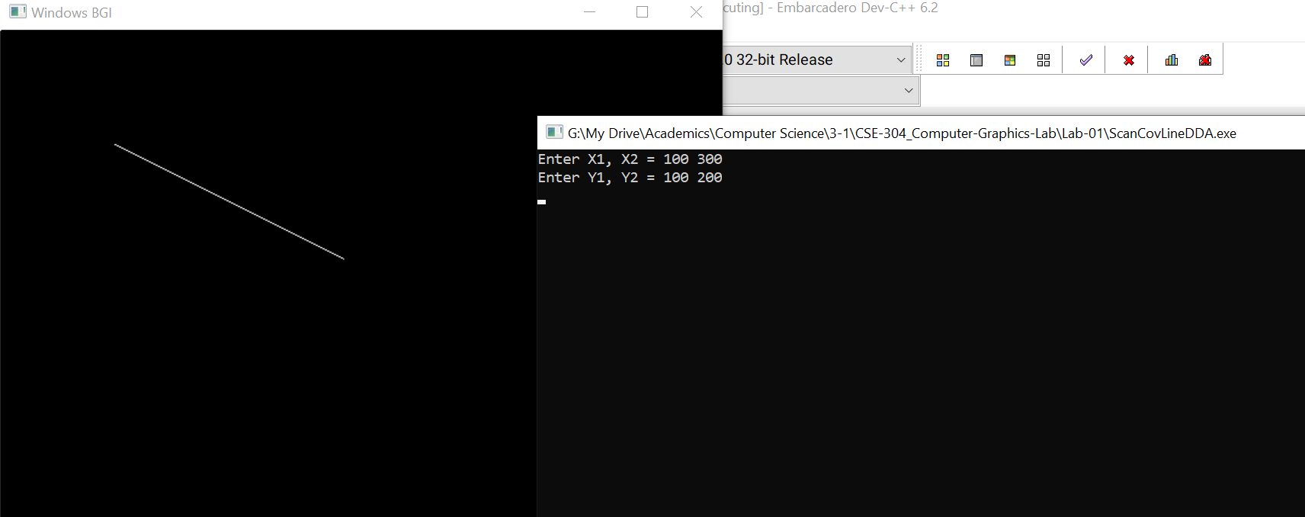

# Algorithm Title: Line Scan Conversion using Bresenham’s Line Algorithm

# Source Code:

#include <graphics.h>

void drawLine(int x1, int y1, int x2, int y2) {

int dx = abs(x2 - x1);

int dy = abs(y2 - y1);

int sx = (x1 < x2) ? 1 : -1;

int sy = (y1 < y2) ? 1 : -1;

int err = dx - dy;

while (true) {

putpixel(x1, y1, WHITE);

if (x1 == x2 && y1 == y2)

break;

int e2 = 2 * err;

if (e2 > -dy) {

err -= dy;

x1 += sx;

}

if (e2 < dx) {

err += dx;

y1 += sy;

}

}

}

int main() {

int gd = DETECT, gm;

initgraph(&gd, &gm, (char*)"");

int x1, x2, y1, y2;

printf("Enter X1, X2 = ");

scanf("%d%d",&x1, &x2);

printf("Enter Y1, Y2 = ");

scanf("%d%d",&y1, &y2);

drawLine(x1, y1, x2, y2); // Draw the line from (x1, y1) to (x2, y2)

delay(5000); // Delay to show the output

closegraph();

return 0;

}

# GUI Output:

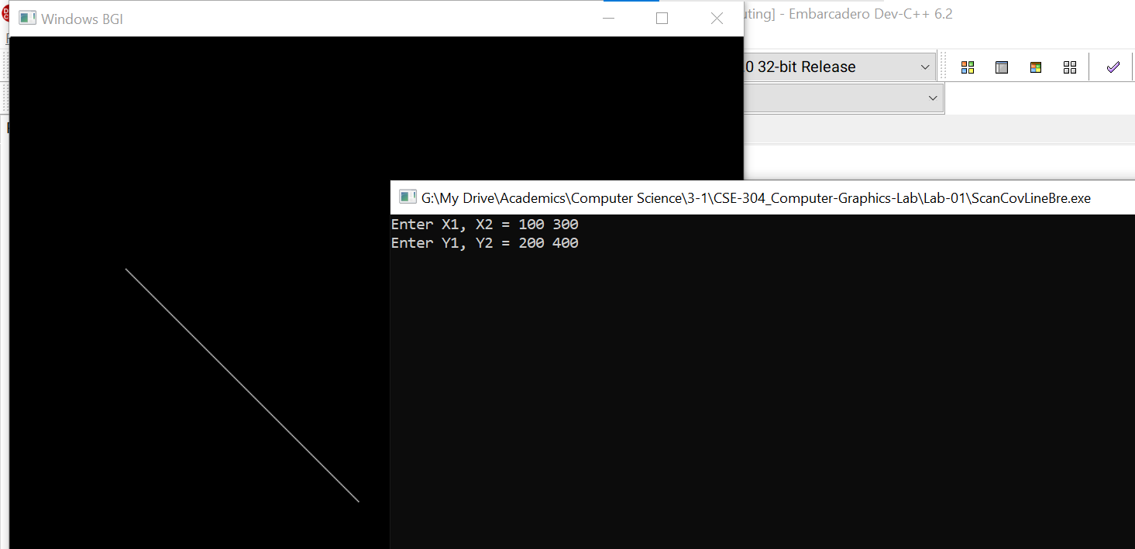

# Algorithm Title: Circle Scan Conversion using Bresenham’s Circle Algorithm

# Source Code:

#include <graphics.h>

void drawCircle(int xc, int yc, int radius) {

int x = 0;

int y = radius;

int d = 3 - 2 * radius;

while (x <= y) {

putpixel(xc + x, yc + y, WHITE);

putpixel(xc - x, yc + y, WHITE);

putpixel(xc + x, yc - y, WHITE);

putpixel(xc - x, yc - y, WHITE);

putpixel(xc + y, yc + x, WHITE);

putpixel(xc - y, yc + x, WHITE);

putpixel(xc + y, yc - x, WHITE);

putpixel(xc - y, yc - x, WHITE);

if (d < 0)

d += 4 * x + 6;

else {

d += 4 * (x - y) + 10;

y--;

}

x++;

}

}

int main() {

int gd = DETECT, gm;

initgraph(&gd, &gm, "");

int xc, yc, radius;

printf("Enter X coordiate of the center: ");

scanf("%d", &xc);

printf("Enter Y co-ordinate of the center: ");

scanf("%d", &yc);

printf("Enter the circle radius: ");

scanf("%d", &radius);

drawCircle(xc, yc, radius); // Draw the circle

delay(5000); // Delay to show the output

closegraph();

return 0;

}

# GUI Output:

